Kurt Leadley

Karie Funk

Keith Kozma

Wendy Portillo

Assignment 2.3 – Group Project (Milestone 1): Team Selection

8/19/2019

**Team Name:** HTML Assassins

**Team Captain:** Kurt Leadley

**Team Members:** Karie Funk, Keith Kozma, Wendy Portillo, Kurt Leadley

**Team Summary:** A rag tag team of functional fur fans, cooks, hikers, guitarists, sports fans and all around programming nerds. We will destroy all competition with our uncanny ability to properly close HTML element tags.

**Proposed Functionality:**

|  |  |  |
| --- | --- | --- |
| **Proposed Function** | **Proposed By** | **Explanation** |
| Application must allow to go back a question if needed | Kurt | I gave it an 8 because it should be implemented, but isn't a feature that would completely ruin the application if it wasn't available. |
| User should be able to see their selected answer in a separate field, to ensure that their preferred answer is "locked in" | Kurt | I gave this a 7 because the user should know that their answer is confirmed before proceeding in the quiz. Without this function, the trust of the user is compromised and the results of the quiz could also be compromised |
| Progress bar displays in the footer or header of the quiz and progress is measured by how many questions (out of the total) they've answered. | Wendy | I gave this a 9 because Progress bars indicator inform the respondent in completing the quiz. It is also help user reassure and encourage he user in completing the quiz |
| Displaying the Quiz Results showResults function to loop over the answers, check them, and show the results. | Wendy | I gave this a 10 to view results to display the results to the question |
| A submit button, next button, and start button | Karie | I gave this an 9 because every quiz should have a sumbit button, next button, and start button for the user to click |
| A hover over for the different answers that the user can choose. | Karie | I give this a 5 because it is not necessary, but is more of an aesthetic feature. I know I like the hover over effect when I'm deciding on an answer to choose. |
| User should have the ability to choose a difficulty setting for the kind and amount of questions they will be asked before they begin the quiz. | Keith | This is ranked an 8 because the user should have the option to test their knowledge dependent on their level of comfort with the subject matter. To accommodate for this, I propose, 3 difficulties: easy, moderate, difficult. Easy setting will be 3-5 questions, moderate 5-10, difficult, 10-15. |
| User should have the option to scale text sizes if needed, for accessibility concerns as well as optional black and white color toggle. | Keith | Taking accessibility into consideration, a scalable text size option as well as a color pallet that meets WCAG standards has the capability to appeal to a wider audience. However, if the color pallet does not appeal to the user, they may have the option to remove all color with a black and white toggle. |

Bio Images:

Kurt Leadley



Karie Funk

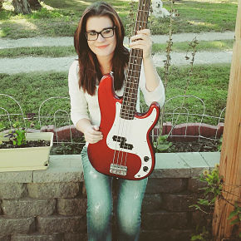

Wendy Portillo

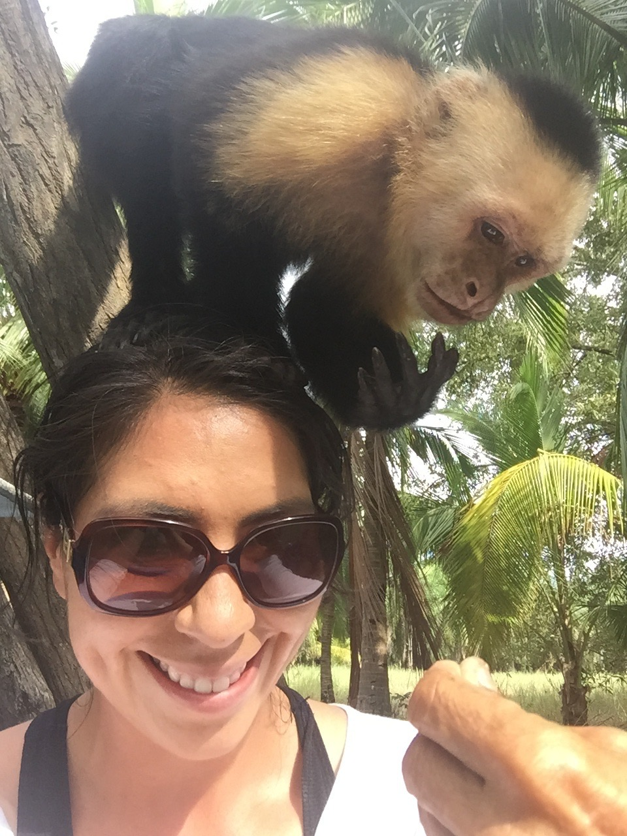

Keith Kozma

